**CS590BD Lab Assignment 1**

**Part 2:** Installation of Cloudera and Map Reduce Application.

The image of the cloudera was downloaded from the link provided. The zip file was unzipped to the Cloudera Image file. Vmware software was installed and opened to add the image as shown.

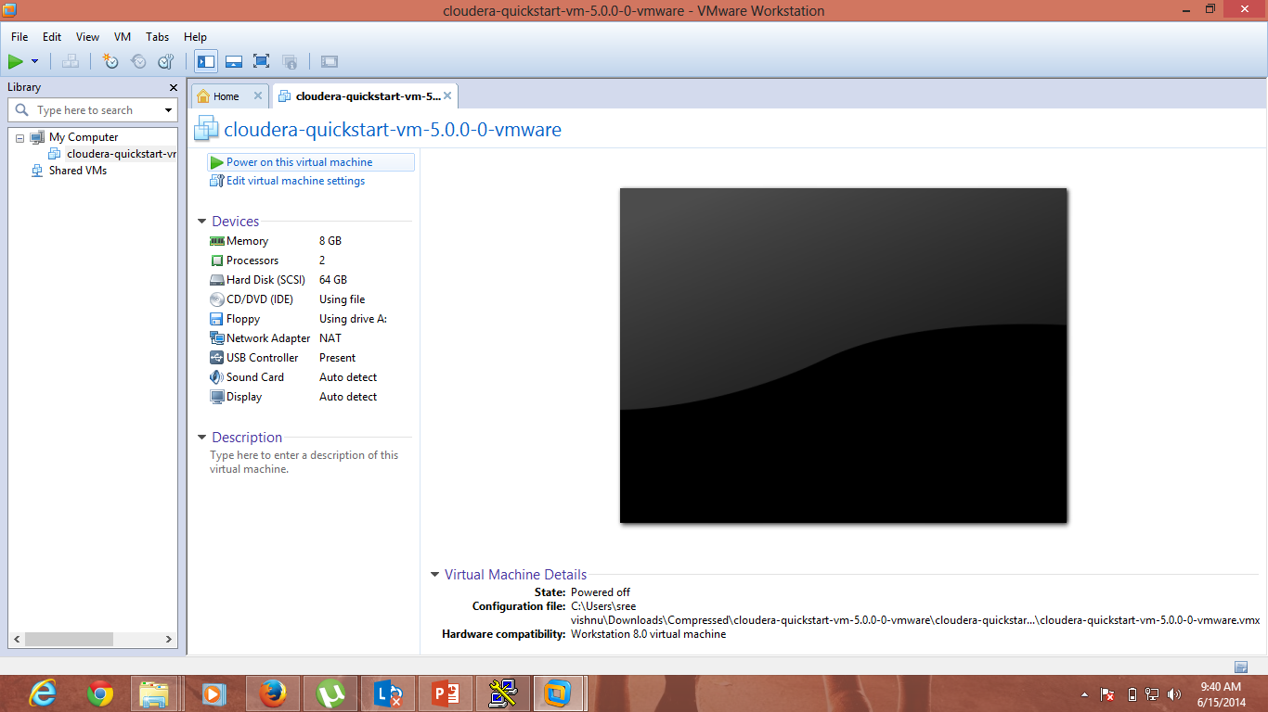

To check the map reduce jobs run and statistics the homepage for cloudera was used.

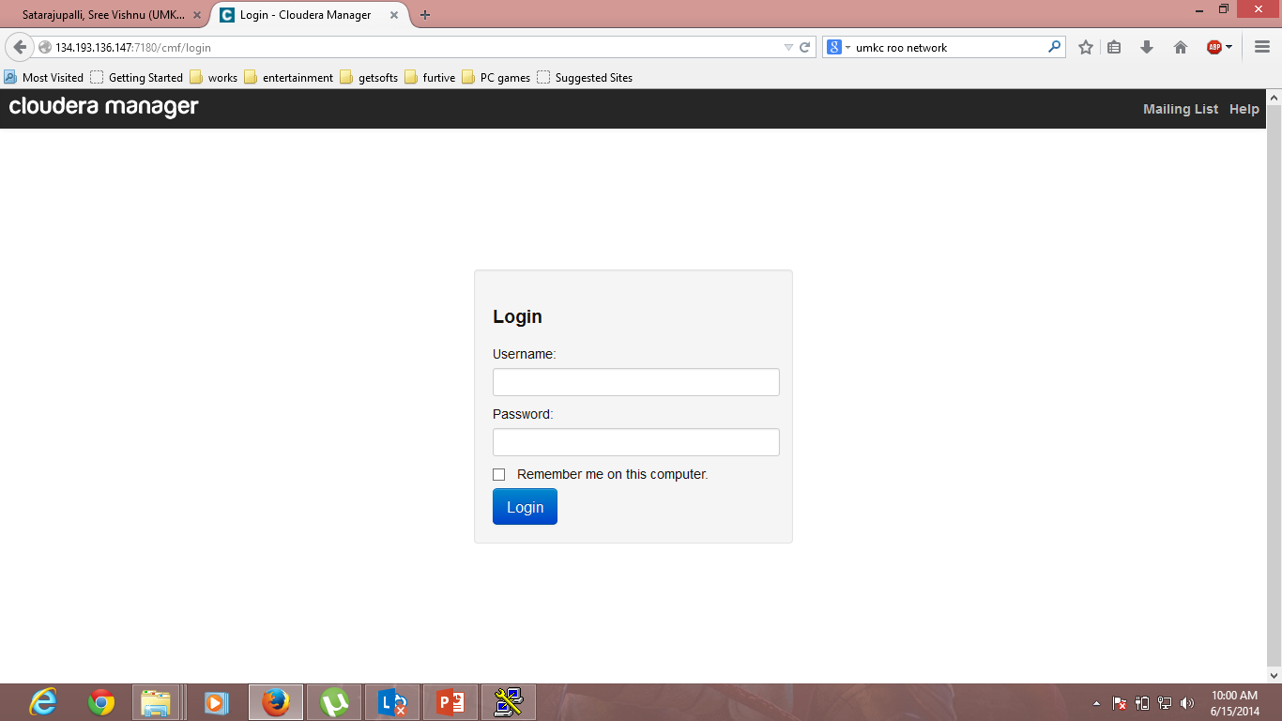

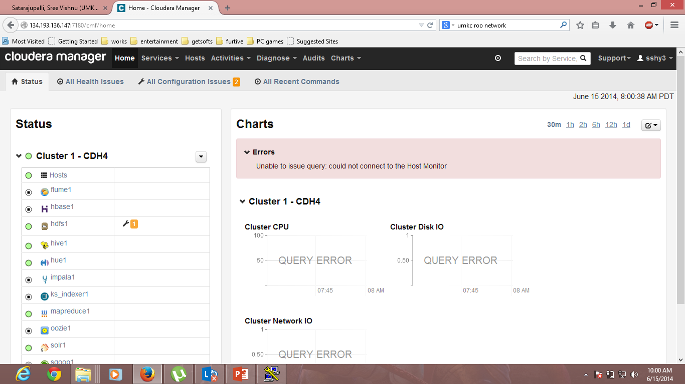

Winscp was can be used to transfer the files from local to cloudera drive.

Wordcount mapreduce program was transferred to the cloudera storage.

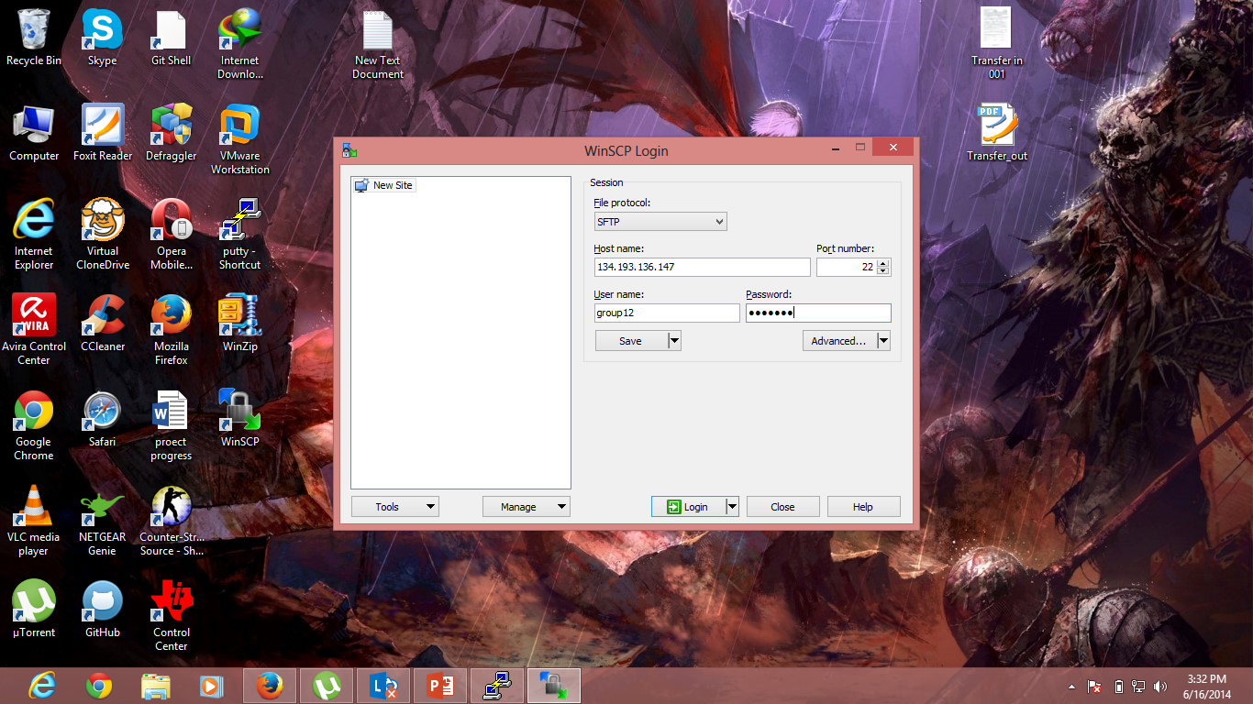

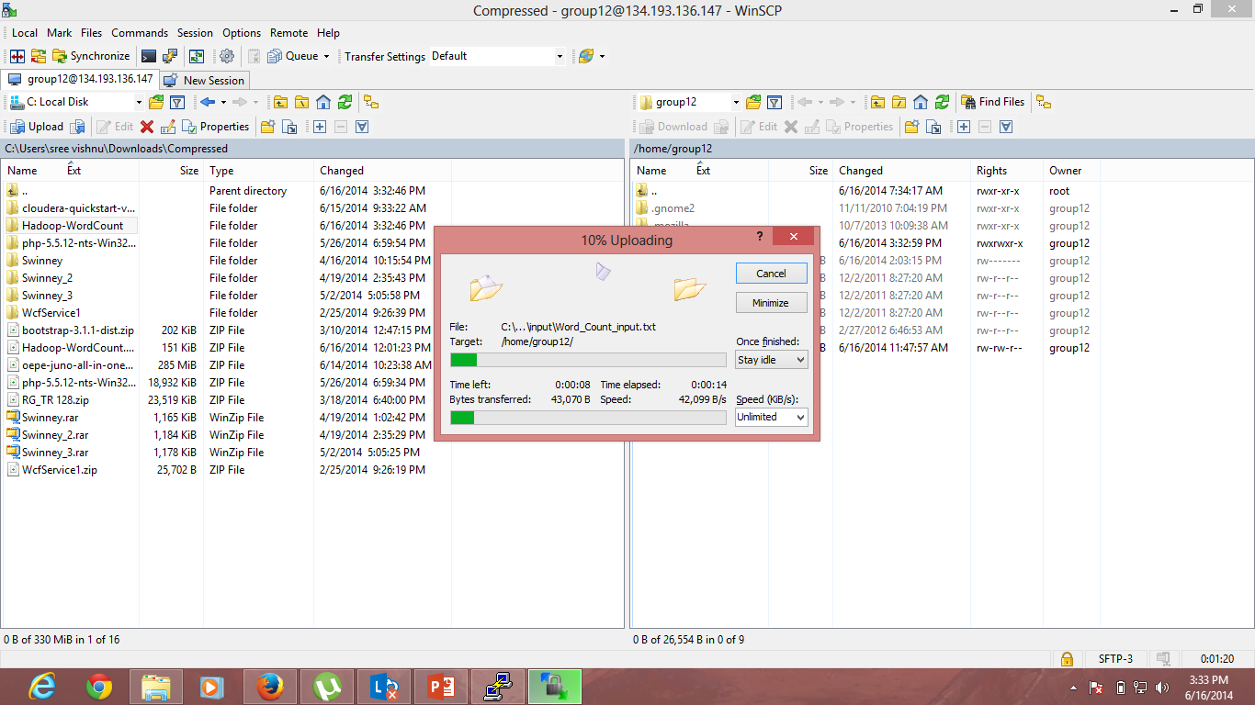

Putty was used to connect to the Cloudera.

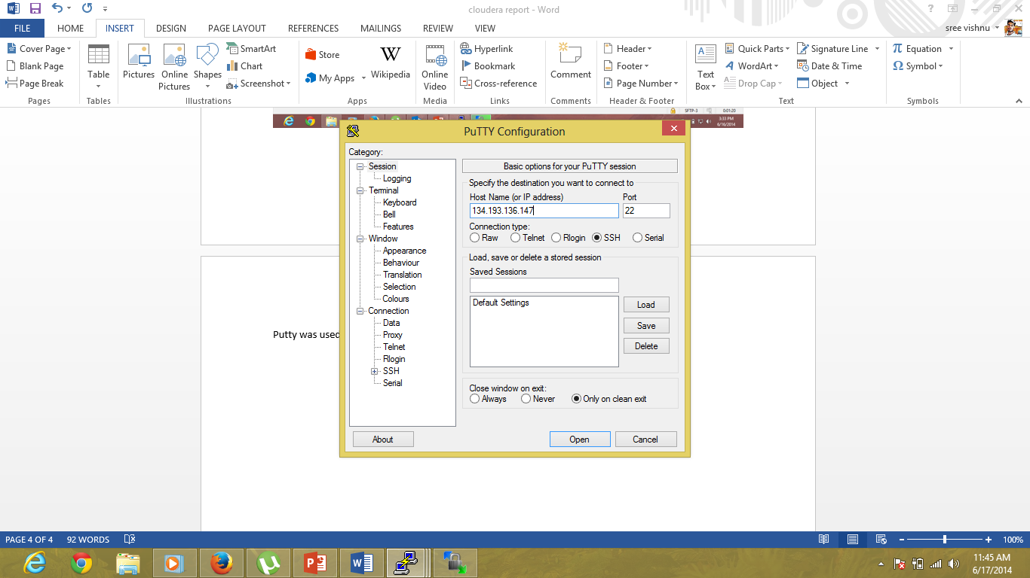

As I had a problem with the cloud with group12 credentials. I have used group11 credentials.

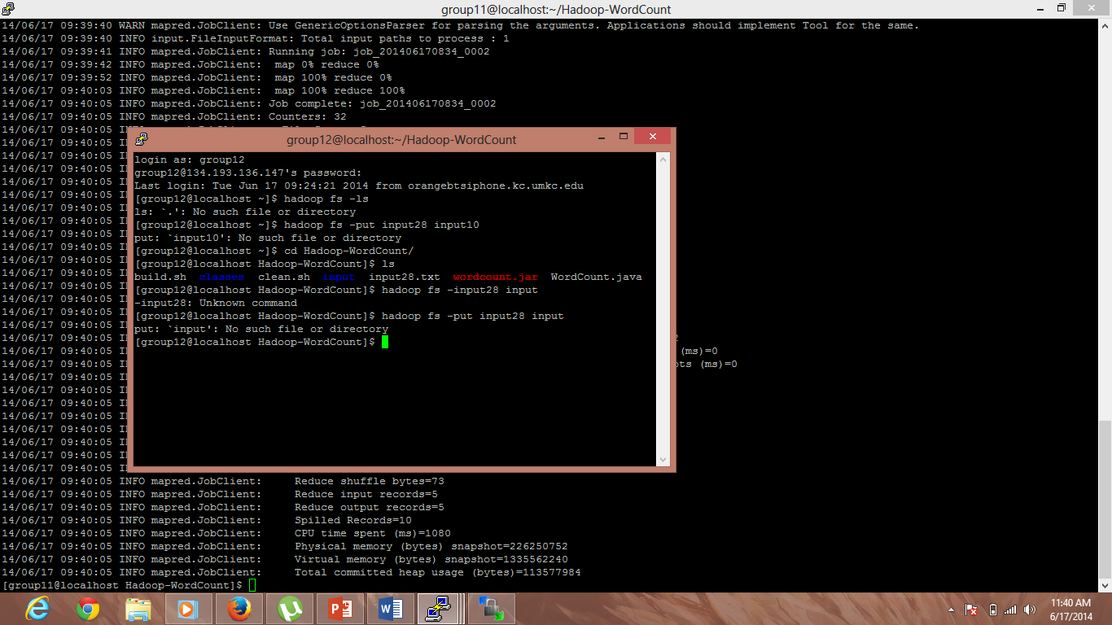

Input28 was created with the text “ task is divided into subtask subtask is divided into subtask”.

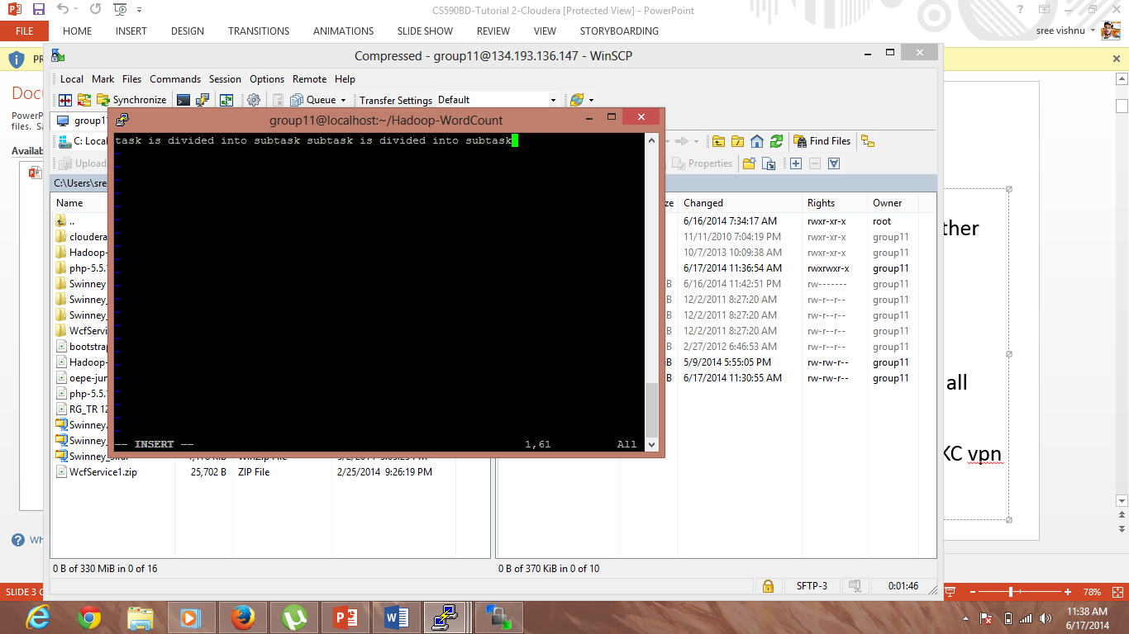

Input28 was send to the cloud storage.

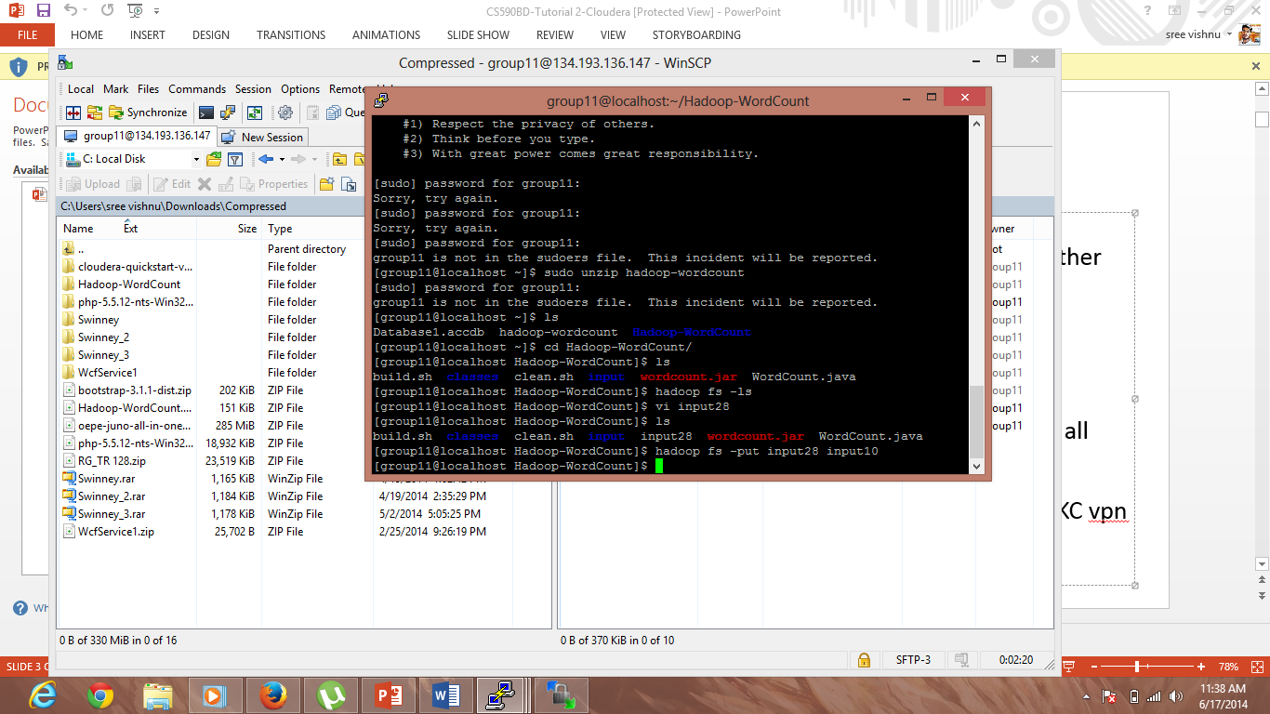

WordCount program was run.

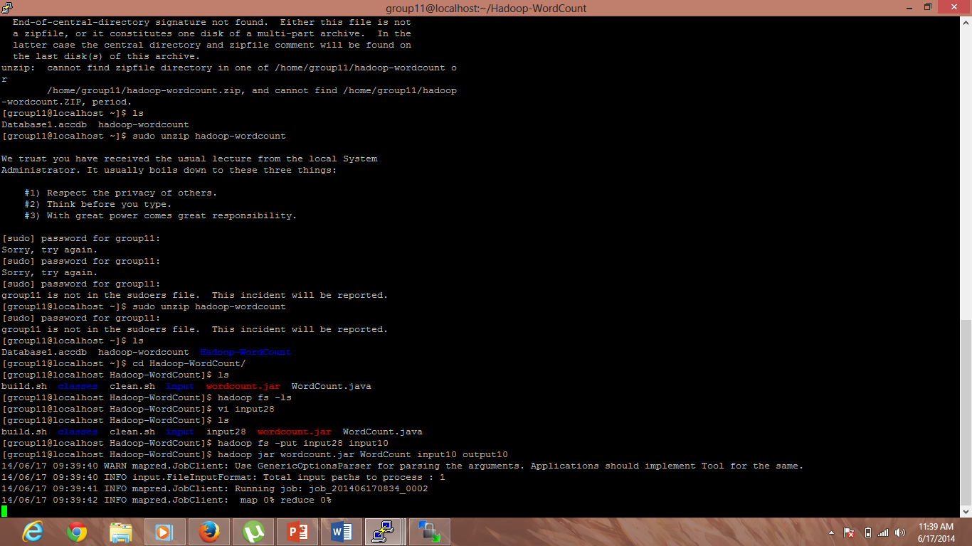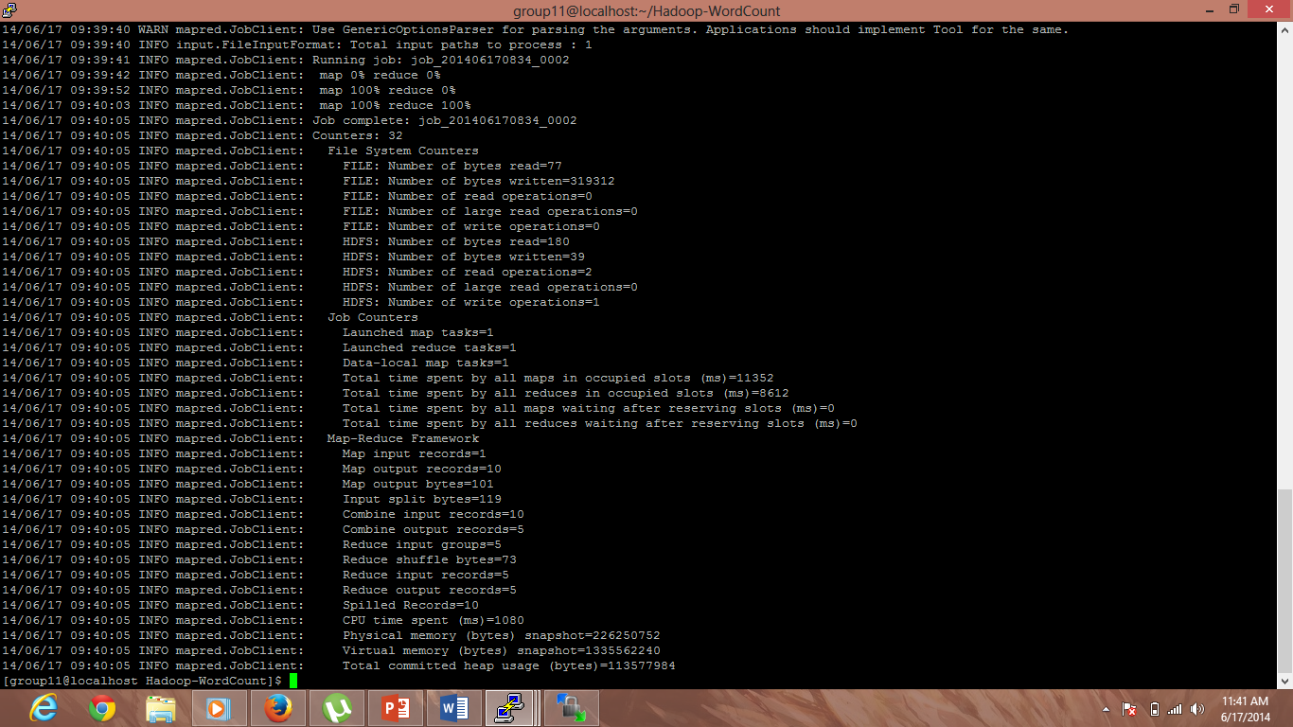

Output was viewed:

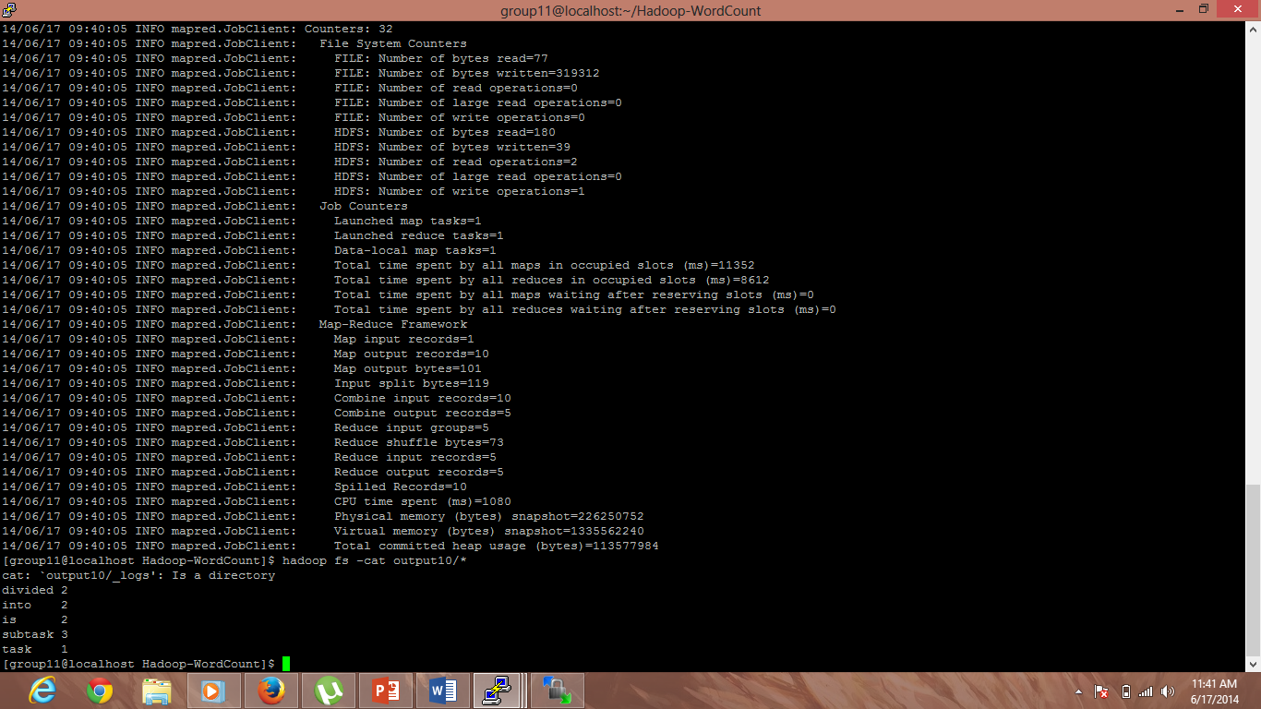

Output got was:

Divided 2

Into 2

Is 2

Subtask 3

Task 1.